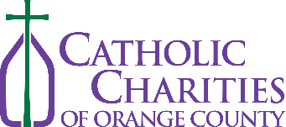
OFFICIAL ENTRY FORM for “Working on my Wings” artwork
By signing below, I acknowledge that I am a Parent/ Legal Guardian of the entrant and give my consent to enter the contest. I understand that the entry will become property of Catholic Charities of Orange County to be used as part of their Marketing and Communications portfolio.
Name:
Catholic High School: Parent/ Legal Guardian Signature: _________________________
Grade: Parent/ Legal Guardian Phone Number: _____________________
Title of artwork (10 words max.):
Description: This year’s theme for our Doodle for Charities art competition is called “Working on my Wings.” We ask participants to incorporate the design of angel wings with our Catholic Charities logo.
_ _ _ _ _ _ _ _ _ _ _ _ _ _ _ _ _ _ _ _ _ _ _ _ _ _ _ _ _ _ _ _ _ _ _ _ _ _ _ _ _ _ _ _ _ _ _ _ _ _ _ _ _ _ _ _ _ _ _ _ _ _ _ _ _ _ _ _ _ _ _ _ _ _ _ _ _ _ _ _ _

